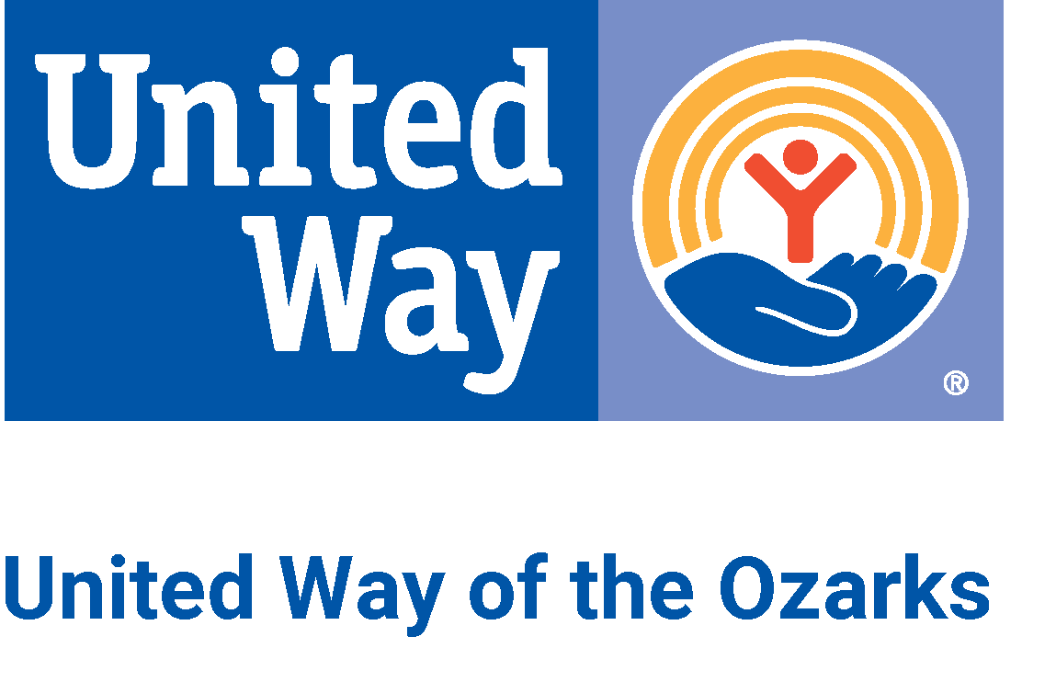
Intern Job Description: Marketing and Communications Intern
Posted: November 16, 2021 - Position open until filled

Description
United Way of the Ozarks (UWO) seeks a dynamic self-starter to assist with marketing and communications efforts. This internship is an excellent opportunity to experience various aspects of marketing while working for a well-known, community-based nonprofit organization.

Responsibilities
- Assist with updating and maintaining UWO’s social media presence, including scheduling Facebook, Instagram and Twitter updates.
- Utilize resources from United Way Worldwide’s communications toolkit and localize materials to be relevant to donors and volunteers in the Ozarks.
- Assist with the design of flyers, graphics and other marketing material for events hosted by UWO.
- Assist with updating the UWO website.
- Assist with organizing and attending weekly marketing committee meetings.
- Assist with outreach to community organizations, public and donors.
- Collaborate with the team on new ideas, directions and venues for marketing and communications.

Qualifications
- Completed or working toward a college degree, preferably in a related field (e.g., English, Marketing/Communications, Graphic Design or Public Relations).
- Self-motivated, good organizational skills, detail-oriented, ability to prioritize, multi-task and meet deadlines.
- Ability to communicate professionally with press and community contacts.
- Firm grasp of available tools and platforms in the social media space.
- Must be computer literate (working knowledge of Microsoft Office, Zoom, etc.).
- An excellent communicator, both written and oral.
- Enthusiasm for the mission of United Way of the Ozarks and serving the community.
- Preference given to candidates with related experience in marketing or communications; proficiency in WordPress; and/or knowledge of graphic design.

Start Date
- Spring semester 2022
- Requires a minimum 3-month commitment

Hours
- 10-15 hours/week, divided between at least three shifts per week.
- Potential for remote work hours.

Compensation
- This is an unpaid internship.
- United Way will work with intern’s college or university to support class credit if desired.

To Apply
- Please send cover letter and resume to SFunderburk@uwozarks.org.

